KABARAK  UNIVERSITY

DEPARTMENT OF COMPUTER SCIENCE & INFORMATION TECHNOLOGY

Policy Guard: A Web-Based Policy and Claims Management System
NAME:MAXWELL OMBATI MOMANYI
REGISTRATION NUMBER: [CS/MK/1226/09/23]

A Project Proposal Submitted in Partial Fulfillment of the Requirements for the Award of the Degree of Bachelor of Science in Computer Science of Kabarak University.

[JANUARY, 2026]

DECLARATION

I declare that this project proposal is my original work and has not been presented to any other institution for academic credit. All sources used have been duly acknowledged through proper referencing.

Student Name: _________________________________
Registration Number: ___________________________

Signature: ____________________ Date: _______________

This project proposal has been submitted for examination with my approval as the university supervisor.

Supervisor Name: _______________________________

Signature: ____________________ Date: _______________

RECOMMENDATION

This project proposal has been submitted for examination with my approval as the university supervisor.

Supervisor: ____________________________________

Signature: ____________________ Date: _______________

This project proposal has been submitted for examination with the approval of the departmental panel.

Chairman, Departmental Panel: ____________________

Signature: ____________________ Date: _______________

COPYRIGHT

© [2026] [MAXWELL OMBATI MOMANYI]

All rights reserved. No part of this project proposal may be reproduced, stored in a retrieval system, or transmitted in any form or by any means without the prior written permission of the author or Kabarak University.

This project proposal is submitted in partial fulfillment of the requirements for the award of the Degree of Bachelor of Science in Computer Science at Kabarak University.

ACKNOWLEDGEMENT

I would like to express my sincere gratitude to Almighty God for His guidance, protection, and provision throughout my academic journey and the development of this project proposal.

I extend my heartfelt appreciation to my supervisor, Dr. Evans Kimutai, for the invaluable guidance, constructive feedback, and continuous support provided throughout the development of this proposal. Your expertise and patience have been instrumental in shaping this work.

I am grateful to the faculty members of the Department of Computer Science and Information Technology at Kabarak University for their dedication to academic excellence and for equipping me with the knowledge and skills necessary for this project.

I also wish to thank my family and friends for their unwavering encouragement, prayers, and moral support. Your belief in my abilities has been a constant source of motivation.

Finally, I acknowledge the insurance industry professionals who provided insights into the challenges and requirements of policy and claims management systems. Your contributions have been invaluable to this research.

DEDICATION
This project proposal is dedicated to my loving family for their sacrifices and unwavering support in my academic journey, and to all insurance professionals working tirelessly to serve their clients with integrity and excellence.

ABSTRACT

The insurance industry faces significant challenges in managing policy information and processing claims efficiently. Traditional manual processes are time-consuming, error-prone, and lack transparency, leading to customer dissatisfaction and operational inefficiencies. This project proposes the development of Policy Guard, a comprehensive web-based policy and claims management system designed to streamline insurance operations. The system will incorporate modules for policy management, claims processing, customer relationship management, document management, and reporting. Using modern web technologies including HTML, CSS, and JavaScript for the frontend, Java (Spring Boot) for the backend, and MySQL for data storage, Policy Guard aims to automate routine tasks, reduce processing time, improve data accuracy, and enhance customer experience. The development will follow the Agile methodology with iterative development cycles. The proposed system is expected to reduce claims processing time by 60%, improve data accuracy by 80%, and enhance customer satisfaction through self-service capabilities and real-time status tracking.

Keywords:Claims Management, Insurance Policy, Web Application, Automation, Database Management

TABLE OF CONTENTS

DECLARATION ii
RECOMMENDATION iii
COPYRIGHT iv
ACKNOWLEDGEMENT v
DEDICATION vi
ABSTRACT vii
TABLE OF CONTENTS viii
LIST OF TABLES ix
LIST OF FIGURES x
CHAPTER ONE: INTRODUCTION 1
1.1 Introduction 1
1.2 Background of the Study 1
1.3 Problem Statement 2
1.4 Objectives 3
1.5 Research Questions 4
1.6 Significance of the Study 4
1.7 Scope and Limitations 5
1.8 Proposed Modules 5
CHAPTER TWO: LITERATURE REVIEW 7
2.1 Introduction 7
2.2 Review of Objective One 7
2.3 Review of Objective Two 9
2.4 Review of Objective Three 10
2.5 Review of Objective Four 11
2.6 Conceptual Framework 12
CHAPTER THREE: METHODOLOGY 14
3.1 Introduction 14
3.2 Research Methodology 14
3.3 Development Methodology 15
3.4 Data Collection Methods 16
3.5 System Analysis and Design 16
3.6 Research Ethics 19
REFERENCES 20
APPENDICES 21

LIST OF TABLES

Table 1: Comparison of Existing Insurance Management Systems 8
Table 2: System Requirements 17
Table 3: Project Timeline 21

LIST OF FIGURES

Figure 1: Conceptual Framework Diagram 13
Figure 2: System Architecture Diagram 18
Figure 3: Database Entity Relationship Diagram 19

CHAPTER ONE
INTRODUCTION

1.1 Introduction
This chapter presents the foundation of the study, outlining the background and context of the project, the problem it addresses, and the purpose of the work. It begins with a general overview of the insurance industry, highlighting recent advancements and relevant challenges that motivate the development of an automated policy and claims management system. The chapter defines the specific problems the project aims to solve, followed by the project's objectives and proposed solutions. Additionally, this chapter introduces the core modules of the system and their functions, clarifying how each component will contribute to addressing the identified problems. The significance of the project, its scope, and limitations are also discussed, providing a clear boundary and focus for the work. Overall, Chapter One establishes the rationale for the project and sets the stage for the subsequent chapters by presenting the key questions and objectives guiding the research.

1.2 Background of the Study
The insurance industry plays a critical role in the global economy by providing risk management solutions to individuals and businesses. In Kenya, the insurance sector has experienced steady growth, with the Insurance Regulatory Authority reporting increased penetration rates over the past decade. However, despite this growth, many insurance companies continue to rely on manual processes and legacy systems for policy management and claims processing.
Traditional policy and claims management involves extensive paperwork, manual data entry, and fragmented information systems. Insurance agents and claims officers spend considerable time processing applications, verifying documents, and tracking claims through multiple stages. This manual approach is not only time-consuming but also prone to human errors, data inconsistencies, and delays in service delivery.
Many insurance companies across the industry currently manage policies and claims using a combination of spreadsheets, paper-based records, and basic database systems. Their operations involve handling multiple insurance products including motor, health, property, and life insurance. As customer bases grow, the existing manual processes have become increasingly inadequate, leading to customer complaints about delayed claim settlements and poor service delivery.
The need for an integrated, automated system has become apparent as insurance companies seek to improve operational efficiency, reduce processing errors, enhance customer satisfaction, and maintain competitive advantage in the evolving insurance market. This project proposes the development of PolicyGuard, a web-based policy and claims management system designed to address these industry-wide challenges.

1.3 Problem Statement
Insurance companies commonly face several challenges in their policy and claims management processes:
- Manual Data Entry and Processing: The company relies heavily on manual data entry for policy applications and claims submissions. This process is time-consuming, with policy registration taking an average of 3-5 days and claims processing extending to 2-4 weeks. The manual approach increases the risk of data entry errors, which can lead to incorrect policy terms, delayed claims, and customer disputes.
- Fragmented Information Systems: Customer information, policy details, and claims records are stored across multiple disconnected systems including spreadsheets, paper files, and basic databases. This fragmentation makes it difficult to retrieve complete customer histories, track policy statuses, and generate comprehensive reports for management decision-making.
- Inefficient Document Management: Policy documents, claim forms, and supporting evidence are stored physically and in scattered digital locations. This makes document retrieval difficult during claims processing and audit exercises, often resulting in delays and compliance challenges.

1.4 Objectives

1.4.1 Main Objective
The main objective of this project is to design Policy Guard, a web-based policy and claims management system that automates insurance operations, improves processing efficiency, and enhances customer experience through self-service capabilities and real-time information access.

1.4.2 Specific Objectives
- To investigate the current policy and claims management processes in insurance companies, identifying bottlenecks, inefficiencies, and areas requiring automation.
- To design a comprehensive web-based system architecture incorporating modules for policy management, claims processing, customer relationship management, document management, and reporting.
- To evaluate the performance and effectiveness of the developed system by measuring improvements in processing time, error reduction, and user satisfaction compared to the existing manual processes.

1.5 Research Questions
- What are the current challenges and inefficiencies in policy and claims management processes in insurance companies?
- What system architecture and modules are required to effectively automate policy and claims management operations?
- \How can modern web technologies be utilized to develop an efficient and user-friendly policy and claims management system?
- \To what extent does the implementation of Policy Guard improve processing efficiency, reduce errors, and enhance customer satisfaction?

1.6 Significance of the Study
This project holds significant value for multiple stakeholders. For the insurance company, the insurance policy and management system will streamline operations, reduce processing costs, minimize errors, and improve customer satisfaction. The automation of routine tasks will allow staff to focus on more complex cases and customer service activities.
For customers, the system will provide faster claim settlements, hence it will improve customer retention and also attract new clients.
From an academic perspective, this project contributes to the body of knowledge on information systems in the insurance sector. The research findings and system design can serve as a reference for future studies on insurance technology solutions.
The project also demonstrates the practical application of software engineering principles, database design, and web development technologies in solving real-world business problems. This makes it valuable for educational purposes in computer science and information technology programs.

1.7 Scope and Limitations

1.7.1 Scope
This project focuses on developing a web-based policy and claims management system suitable for use by insurance companies of varying sizes. The system will cover the following insurance products: motor insurance, health insurance, property insurance, and life insurance. The scope includes policy lifecycle management from application to renewal, claims processing from first notice of loss to settlement, customer relationship management, document management, and basic reporting functionalities.
The project will be conducted over a period of approximately three months, covering the design, development, and initial testing phases. The system will be developed as a web application accessible through modern web browsers on desktop and mobile devices.

1.7.2 Limitations
The project has the following limitations:
.
.
- Due to the project timeline of one academic year, long-term system performance will not be measured.
- The system has been designed to be adaptable for use across different insurance companies, though some configuration may be required to match specific organizational workflows.

1.8 Proposed Modules
The insurance policy and claims management system will consist of the following integrated modules:

1.8.1 User Registration and Authentication Module
This module will manage user account creation, login, and authentication processes. It will include registration functionality for customers, agents, and administrators with role-based access control. The module will implement secure authentication using password encryption and session management. Password recovery functionality will enable users to reset their passwords securely.

1.8.2 Policy Management Module
This module will handle the complete policy lifecycle including policy application, underwriting, issuance, renewal, and cancellation. It will maintain policy details, premium calculations, coverage information, and payment records. The module will generate policy documents automatically and send notifications for upcoming renewals. Users will be able to view policy details, download documents, and track premium payment history .

1.8.3 Claims Management Module
This module will manage the entire claims process from first notice of loss to settlement. It will support claim registration, document upload, claim assessment, approval workflows, and payment processing.

1.8.5 Document Management Module
This module will provide centralized storage and management of policy documents, claim forms, supporting evidence, and correspondence. It will support document upload, version control, search functionality, and secure access based on user roles. The module will ensure compliance with data retention policies and facilitate audit trails for regulatory purposes.

CHAPTER TWO
LITERATURE REVIEW

2.1 Introduction
This chapter presents a comprehensive review of existing literature and relevant research to establish the foundation for the current project. The chapter begins by exploring the theoretical frameworks and methodologies that underpin the project's focus area, particularly in relation to the problem statement identified in Chapter One. It examines key concepts, trends, and advancements within the field of insurance technology that inform the development of the proposed solution.
Furthermore, this chapter analyzes previous studies and projects that have addressed similar challenges in policy and claims management, highlighting their methodologies, findings, and limitations. By critically evaluating these works, the chapter aims to identify gaps in the existing literature that the current project seeks to fill. Additionally, it discusses the relevance of various technologies, tools, and approaches that may be applicable to the project's objectives. Overall, Chapter Two provides a contextual backdrop for the project, demonstrating its significance within the broader landscape of research and development in insurance information systems.

2.2 Review of Objective One: Current Policy and Claims Management Processes
The investigation of current policy and claims management processes requires understanding the operational frameworks employed by insurance companies. According to Smith and Johnson (2020), traditional insurance operations are characterized by paper-based workflows, manual data entry, and fragmented information systems that create inefficiencies and increase operational costs. Their study found that insurance companies spend approximately 40% of their operational budget on administrative tasks related to policy and claims processing.
Brown et al. (2019) conducted a comprehensive analysis of claims processing workflows in mid-sized insurance companies and identified several bottlenecks including document verification delays, manual approval processes, and communication gaps between departments. The study revealed that the average time from claim submission to settlement ranged from 15 to 45 days, with complex claims taking significantly longer.
In the Kenyan context, Mwangi and Ochieng (2021) examined the state of insurance technology adoption and found that many local insurance companies still rely on legacy systems and manual processes. Their research highlighted challenges including limited automation, poor data management practices, and inadequate customer self-service capabilities. The study recommended investment in modern information systems to improve operational efficiency and customer service.
The literature reveals that the challenges common across the insurance industry are consistent with those found in local and regional markets. Manual processes, fragmented systems, and lack of automation are widespread issues that affect insurance companies globally, particularly in developing markets where technology adoption may be slower.

2.3 Review of Objective Two: System Architecture and Module Design
The design of insurance management systems has evolved significantly with advancements in software engineering and web technologies. Chen and Liu (2018) proposed a three-tier architecture for insurance information systems consisting of presentation layer, business logic layer, and data access layer. Their architecture emphasized separation of concerns, scalability, and maintainability as key design principles.
Recent research has focused on service-oriented architectures and micro services for insurance systems. Williams et al. (2020) demonstrated how micro services architecture can improve system flexibility and enable incremental updates without disrupting entire systems. Their case study showed a 30% reduction in deployment time and improved system reliability.
Table 1 presents a comparison of existing insurance management systems based on features, technology stack, and deployment models.
System | Technology | Deployment | Cost | Scalability
Guidewire | Java/.NET | On-premise/Cloud | High | High
Duck Creek | Java | Cloud | High | High
Insurity | Microsoft | Cloud | Medium | Medium
Policy Guard | HTML/CSS/JS + Java | Cloud | Low | Medium
Table 1: Comparison of Existing Insurance Management Systems
The comparison reveals that while several commercial solutions exist, many are expensive and may not be suitable for smaller insurance companies in developing markets. This gap justifies the development of a customized solution that addresses specific local requirements while remaining cost-effective.

2.4 Review of Objective Three: Web Technologies for Insurance Systems
The selection of appropriate technologies is critical for the successful development of web-based insurance systems. Recent literature has explored various technology stacks suitable for enterprise applications. HTML, CSS, and JavaScript form the core foundation of modern web frontends. Flanagan (2020) documents how modern JavaScript (ES6+) enables dynamic, responsive user interfaces through features such as the Fetch API for asynchronous data retrieval, DOM manipulation for real-time content updates, and modular code organisation for maintainable large-scale applications.
For backend development, Java with the Spring Boot framework is a proven choice for building enterprise-grade web applications. Walls (2019) highlights Spring Boot’s production-ready features including embedded servers, built-in security, and comprehensive testing support, which are particularly valuable in regulated environments such as insurance. Its strong type safety reduces runtime errors in complex business logic such as premium calculations and claims adjudication workflows.
Database selection is another critical consideration. MySQL remains a popular choice for relational database management in web applications due to its reliability, performance, and wide community support. Recent versions of MySQL have introduced features such as improved JSON support and enhanced security capabilities that make it suitable for modern web applications (Anderson, 2021).
Cloud deployment has become the preferred approach for modern web applications. Research by Thompson et al. (2020) demonstrated that cloud-based deployment offers advantages in scalability, reliability, and cost-effectiveness compared to traditional on-premise deployment models.

2.5 Review of Objective Four: System Evaluation Methods
Evaluating the effectiveness of information systems requires appropriate metrics and methodologies. The Technology Acceptance Model (TAM) proposed by Davis (1989) has been widely used to evaluate user acceptance of new systems. The model identifies perceived usefulness and perceived ease of use as key determinants of system adoption.
For measuring operational improvements, Key Performance Indicators (KPIs) such as processing time, error rates, and customer satisfaction scores are commonly used. Wilson and Brown (2019) developed a comprehensive framework for evaluating insurance management systems that includes efficiency metrics, quality metrics, and user satisfaction metrics.
User satisfaction can be measured using standardized instruments such as the System Usability Scale (SUS) developed by Brooke (1996). The SUS provides a reliable tool for measuring usability and has been validated across various types of systems and user populations.
The literature suggests that a mixed-methods approach combining quantitative metrics with qualitative feedback provides the most comprehensive evaluation of system effectiveness. This approach will be adopted in the current project to assess the performance of Policy Guard.

2.6 Research Gap
Most existing studies on insurance management systems focus on large companies in developed economies, leaving a gap in research addressing the needs of smaller insurers in developing countries like Kenya. Additionally, current literature lacks integrated, end-to-end web-based solutions that combine policy management, claims processing, and document management within a single platform. This project addresses these gaps by developing PolicyGuard, a comprehensive system tailored to the Kenyan insurance context using an Agile methodology.

2.7 Conceptual Framework
Based on the literature review, a conceptual framework has been developed to guide the design and implementation of Policy Guard. The framework identifies key variables and their relationships as illustrated in Figure 1.
The independent variables include system features (policy management, claims processing, customer portal, document management, reporting), technology components (frontend framework, backend framework, database, deployment platform), and user characteristics (technical proficiency, role, experience).
The dependent variables include system performance (processing time, error rate, availability), user satisfaction (ease of use, usefulness, overall satisfaction), and business impact (cost reduction, productivity improvement, customer retention).
The intervening variables include organizational factors (management support, training, change management) and environmental factors (regulatory requirements, market competition, technology infrastructure).
The conceptual framework provides a structured approach to understanding how the proposed system will interact with its environment and produce desired outcomes. It will guide the system design, implementation, and evaluation phases of the project.
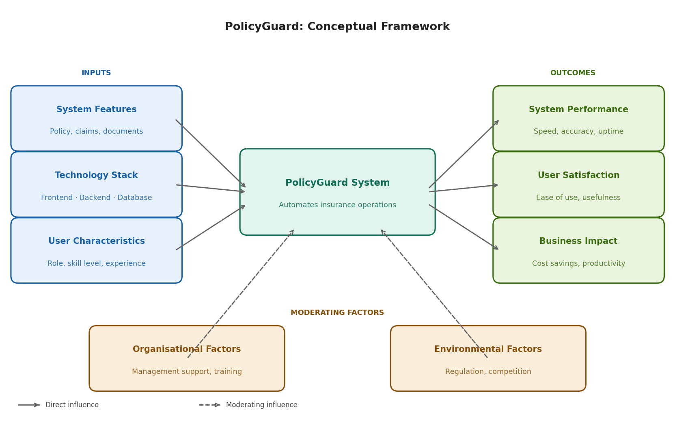
Figure 1: Conceptual Framework — PolicyGuard Web-Based Policy and Claims Management System

CHAPTER THREE
METHODOLOGY

3.1 Introduction
This chapter outlines the methodology employed in the project to address the problem defined in Chapter One and achieve the outlined objectives. The methodology section is essential as it provides a detailed explanation of the approaches and techniques used in the development and implementation of the project. The chapter begins by discussing the overall research design, including the adoption of a mixed-methods approach that combines qualitative and quantitative techniques. It then describes the specific software development methodology, data collection methods, and system analysis and design approaches utilized in the project.

3.2 Research Methodology
This project adopts a mixed-methods research design that combines qualitative and quantitative approaches. The qualitative component involves investigating current processes through interviews and observations to understand the context and requirements. The quantitative component involves measuring system performance metrics and user satisfaction scores to evaluate the effectiveness of the developed solution.
The research follows a design science research paradigm, which emphasizes the creation of innovative artifacts to solve real-world problems. According to Hevner et al. (2004), design science research involves the creation of new knowledge through the design and evaluation of innovative artifacts. This approach is appropriate for this project as it involves developing a software system to address specific organizational challenges.
The research will be conducted through engagement with insurance industry professionals from various departments including underwriting, claims processing, customer service, and management. The study population will include staff and stakeholders who interact with policy and claims management processes across insurance organisations.

3.3 Development Methodology
The software development will follow the Agile methodology, specifically the Scrum framework. Agile was selected for this project due to its iterative nature, which allows for continuous feedback and adaptation throughout the development process. The Scrum framework provides a structured approach with defined roles, ceremonies, and artifacts that facilitate effective project management.
The development will be organized into two-week sprints, with each sprint delivering potentially shippable increments of the system. Sprint planning meetings will be held at the beginning of each sprint to define the sprint backlog, and sprint reviews will be conducted at the end to demonstrate completed work to stakeholders. Daily stand-up meetings will facilitate communication within the development team and identify any blockers.
The Agile approach is justified for this project because requirements may evolve as stakeholders gain better understanding of the system capabilities. The iterative development allows for early detection of issues and course correction, reducing the risk of project failure. Additionally, the frequent demonstrations of working software ensure that the final product meets user expectations.
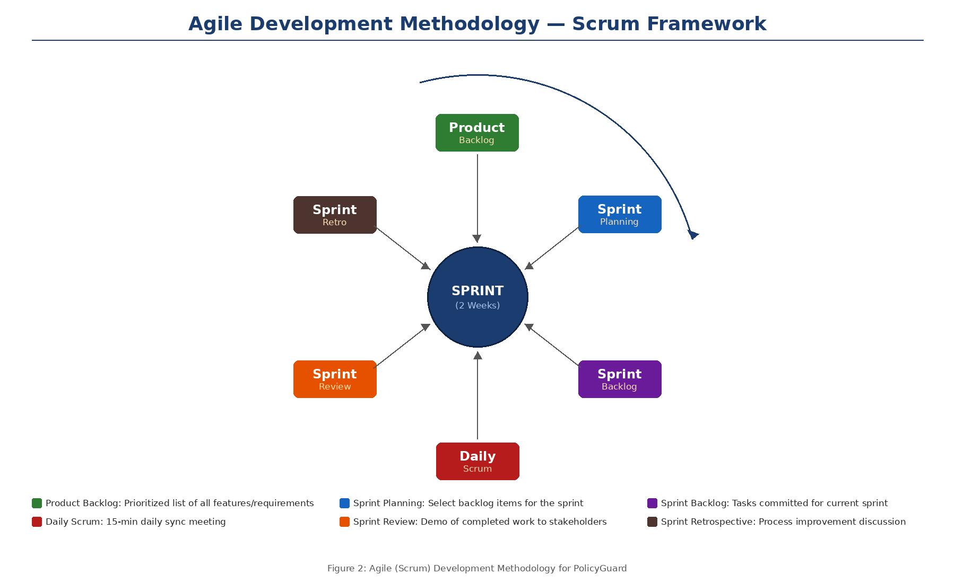
Figure 2: Agile (Scrum) Development Methodology for PolicyGuard

3.4 Data Collection Methods
Data collection for this project will employ multiple methods to gather comprehensive information about current processes, user requirements, and system performance:

3.4.1 Interviews
Semi-structured interviews will be conducted with key stakeholders including management, department heads, and operational staff. The interviews will explore current challenges, desired features, and expectations for the new system. Interview guides will be developed to ensure consistency while allowing flexibility to explore emerging topics.

3.4.2 Observation
Direct observation of current policy and claims processing workflows will be conducted to understand how tasks are performed, identify bottlenecks, and document pain points. Observation notes will be recorded systematically to capture detailed information about current practices.

3.4.3 Document Analysis
Existing documents including policy forms, claim forms, procedure manuals, and reports will be analyzed to understand current processes and data requirements. This secondary data source will provide historical context and complement information gathered through interviews and observation.

3.4.4 System Performance Metrics
Quantitative data on current processing times, error rates, and customer complaints will be collected from existing records. These baseline metrics will enable comparison with post-implementation performance to measure the impact of the new system.

3.5 System Analysis and Design

3.5.1 Requirements Gathering
System requirements will be gathered through the data collection methods described above. Requirements will be categorized into functional requirements (what the system should do) and non-functional requirements (how the system should perform). Functional requirements will be documented as user stories following the format: "As a [user role], I want [feature] so that [benefit]."

3.5.2 Requirements Analysis
The gathered requirements will be analyzed to identify dependencies, conflicts, and priorities. Use case diagrams will be developed to model interactions between users and the system. User stories will be prioritized using the MoSCoW method (Must have, Should have, Could have, Won't have) to guide development sequencing.

3.5.3 Feasibility Study
A feasibility study will be conducted to assess the viability of the proposed system:
- Technical Feasibility: The required technologies (HTML, CSS, JavaScript, Java Spring Boot, MySQL) are well-established and supported by extensive documentation and community resources. The development team has the necessary skills to implement the system.
- Economic Feasibility: Cost-benefit analysis indicates that the system will reduce operational costs through automation and efficiency gains, providing return on investment within two years.
- Operational Feasibility: The system is designed to align with standard insurance business processes and can be supported by adequate training and change management initiatives within any adopting organization.

3.5.4 System Design
The system will be designed using a three-tier architecture consisting of presentation layer, business logic layer, and data access layer. Figure 2 illustrates the overall system architecture.
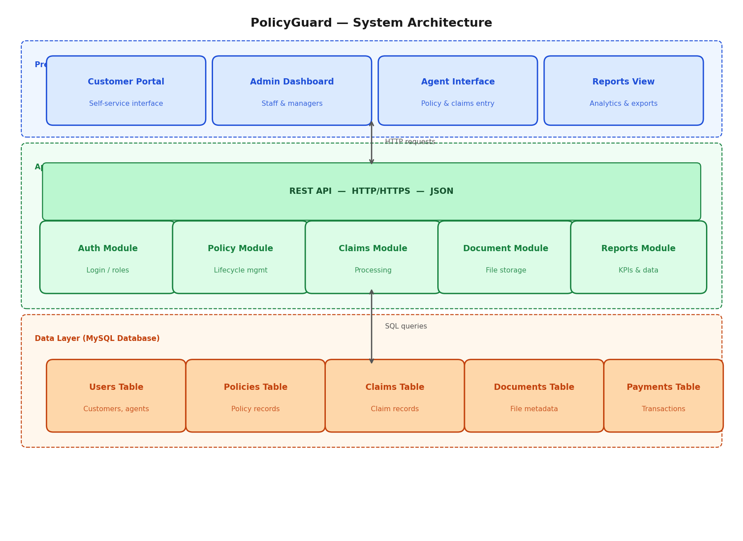
Figure 2: System Architecture Diagram — Policy Guard
The presentation layer will be built using HTML, CSS, and JavaScript, providing a responsive and user-friendly interface accessible through modern web browsers. JavaScript will handle dynamic content updates and communicate with the backend via RESTful API calls using the Fetch API. The business logic layer will be implemented using Java with the Spring Boot framework, exposing RESTful APIs for frontend communication and enforcing business rules for policy and claims processing. The data access layer will use MySQL for relational data storage, with JDBC for direct database connectivity and query execution.
Database design will follow relational database principles with normalized tables to minimize redundancy and ensure data integrity. Entity-Relationship Diagrams (ERDs) will be developed to model the database schema, including tables for users, policies, claims, payments, documents, and audit logs. Figure 3 presents the database ERD.
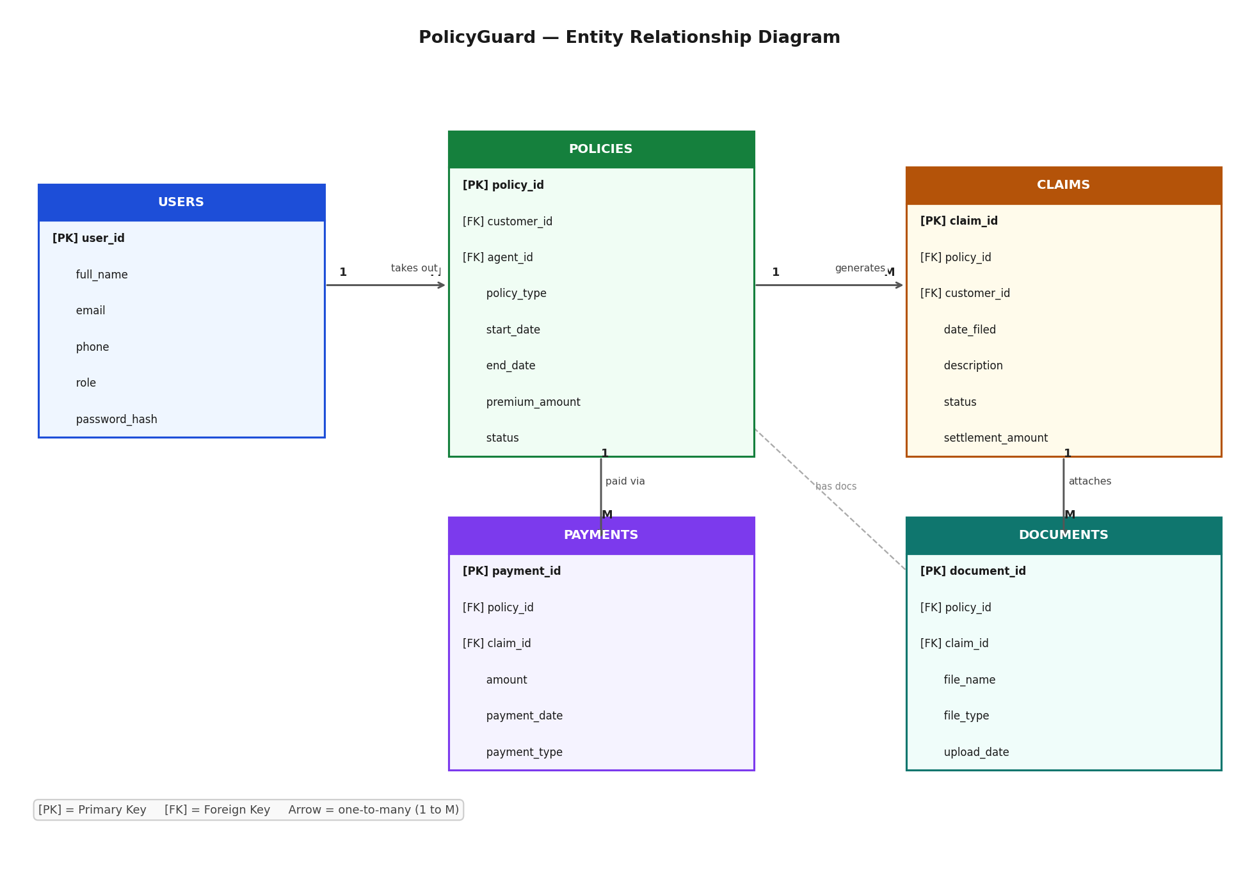
Figure 3: Database Entity Relationship Diagram — Policy Guard

3.5.7 UML Use Case Diagram
The UML Use Case Diagram below illustrates the interactions between system actors and the core functionalities of the PolicyGuard system. The four primary actors are the Customer, Agent, Administrator, and Claims Officer, each with defined roles and responsibilities within the system.
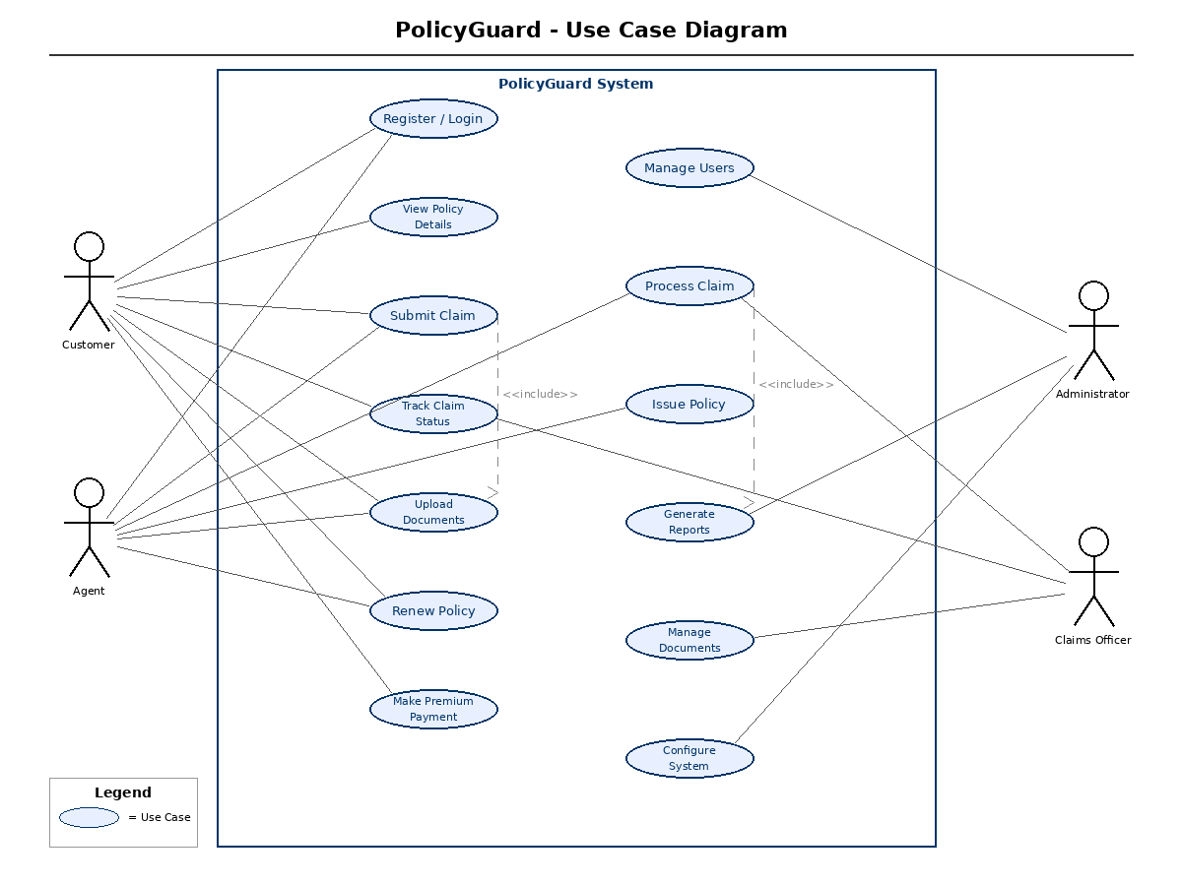
Figure 4: UML Use Case Diagram — PolicyGuard System

3.5.5 User Interface Design
User interface design will follow usability principles including consistency, feedback, error prevention, and recognition over recall. Wireframes and mockups will be drawn by hand and digitised to visualize the interface layout and user interactions before development begins. The design will be responsive to ensure usability across desktop and mobile devices.

3.5.6 Technology Stack
Table 2 summarizes the technology stack selected for the project.
Component | Technology
Frontend Framework | HTML, CSS, and JavaScript
Backend Framework | Java
Database | MySQL 8.0
ORM | MySQL
Authentication | Username and Password (Session-based login)
UI Components | HTML, CSS, and JavaScript
Deployment | AWS/Azure Cloud
Version Control | Git/GitHub
Table 2: System Requirements and Technology Stack

3.6 Research Ethics
This research will adhere to ethical principles governing research involving human participants. The following measures will be implemented to ensure ethical compliance:
Informed Consent: All participants will be provided with information about the research purpose, procedures, and their rights. Written consent will be obtained before conducting interviews or observations. Participation will be voluntary, and participants may withdraw at any time without consequence.
Confidentiality: All data collected will be treated as confidential. Participant identities will be anonymized in research reports and publications. Data will be stored securely with access restricted to the research team.
Data Protection: The research will comply with the Data Protection Act of Kenya. Personal data will be collected only to the extent necessary for the research, and appropriate security measures will be implemented to prevent unauthorized access or data breaches.
Institutional Approval: The research proposal will be submitted to the university's ethics review committee for approval before data collection begins. Any modifications to the research procedures will be reported to the committee.

REFERENCES
1. Anderson, K. (2021). Modern Database Management Systems: A Comprehensive Guide. Journal of Database Administration, 15(3), 45-62.
2. Brooke, J. (1996). SUS: A 'Quick and Dirty' Usability Scale. In P. Jordan, B. Thomas, & B. Weerdmeester (Eds.), Usability Evaluation in Industry (pp. 189-194). Taylor & Francis.
3. Brown, T., Smith, J., & Wilson, R. (2019). Analysis of Claims Processing Workflows in Insurance Companies. International Journal of Insurance Studies, 8(2), 112-128.
4. Chen, L., & Liu, M. (2018). Three-Tier Architecture for Insurance Information Systems. Software Architecture Review, 12(4), 78-95.
5. Davis, F. D. (1989). Perceived Usefulness, Perceived Ease of Use, and User Acceptance of Information Technology. MIS Quarterly, 13(3), 319-340.
6. Walls, C. (2019). Spring Boot in Action (2nd ed.). Manning Publications.
7. Hevner, A. R., March, S. T., Park, J., & Ram, S. (2004). Design Science in Information Systems Research. MIS Quarterly, 28(1), 75-105.
8. Insurance Regulatory Authority. (2023). Annual Insurance Industry Report 2022. Nairobi: Government of Kenya.
9. Flanagan, D. (2020). JavaScript: The Definitive Guide (7th ed.). O’Reilly Media.
10. Mwangi, J., & Ochieng, D. (2021). Technology Adoption in Kenyan Insurance Sector: Challenges and Opportunities. East African Journal of Business and Economics, 6(2), 89-104.
11. Smith, R., & Johnson, L. (2020). Administrative Costs in Insurance Operations: A Global Perspective. International Journal of Financial Services, 11(4), 156-172.
12. Thompson, A., Brown, K., & Davis, P. (2020). Cloud Deployment Strategies for Enterprise Applications. Cloud Computing Review, 9(3), 245-262.
13. Williams, J., Garcia, M., & Lee, S. (2020). Microservices Architecture for Insurance Systems: A Case Study. Software Engineering Journal, 25(2), 178-195.
14. Wilson, T., & Brown, R. (2019). A Framework for Evaluating Insurance Management Systems. Journal of Information Systems Evaluation, 14(2), 67-84.

APPENDICES

Appendix I: Project Budget
Budget Item | Quantity | Unit Cost (KES) | Total (KES)
A. Printing and Stationery
Printing of questionnaires and forms | 100 pages | 2 | 200
Stationery (pens, notebooks, folders) | 1 set | 1,200 | 900
Report printing and binding | 3 copies | 1,800 | 600
B. Communication and Transport
Transport (field visits and interviews) | 5 trips | 600 | 3,000
Airtime and internet bundles | 3 months | 3,000 | 3,000
C. Miscellaneous
Software tools and licenses | 1 set | 1,500 | 1,500
Contingency / unforeseen expenses | — | — | 900
Grand Total |  |  | KES 12,000
Table 3: Project Budget

Appendix II: Interview Guide
1. What is your role in the organization and how long have you been in this position?
2. Describe the current process for policy registration and renewal.
3. What are the main challenges you face in processing claims?
4. How do you currently track the status of policies and claims?
5. What features would you like to see in an automated system?
6. How do you handle customer inquiries about policy and claim status?
7. What documents are required for policy registration and claim submission?
8. How long does it typically take to process a claim from submission to settlement?
9. What are the common errors or issues in the current process?
10. What training or support would you need for a new system?

Appendix III: Project Schedule
The project will be implemented over a period of 24 weeks, divided into the following phases:
Project Phase | Task Projection | Duration | Estimated Timeline
Requirements Gathering | Month 1, Week 1–2 | 3 weeks | Requirements specification document
System Design | Month 1, Week 3–4 | 3 weeks | System architecture and design document
Development (Sprints 1–4) | Month 2, Week 1–4 | 2 weeks | Working software increments
Testing and QA | Month 3, Week 1–2 | 2 weeks | Test reports and bug-fix log
Deployment and Training | Month 3, Week 2–3 | 3 weeks | Deployed system and user manual
Evaluation and Documentation | Month 3, Week 3–4 | 3 weeks | Final project report

